10.6: The Cold War 1945-1991

United Nations
Crumbling Alliance
Iron Curtain
Truman Doctrine and Containment
Marshall Plan
Germany Divided
Berlin Airlift
NATO
Warsaw Pact
Arms Race

Explain the primary cause of the Cold War. TEES

Explain a secondary cause of the Cold War. TEES

The United Nations

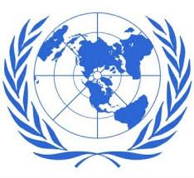

The name "United Nations", coined by United States President Franklin D. Roosevelt was first used in the Declaration by United Nations of 1 January 1942, during the Second World War, when representatives of 26 nations pledged their Governments to continue fighting together against the Axis Powers.
The forerunner of the United Nations was the League of Nations, an organization conceived in similar circumstances during the first World War, and established in 1919 under the Treaty of Versailles "to promote international cooperation and to achieve peace and security." The League of Nations ceased its activities after failing to prevent the Second World War.
In 1945, representatives of 50 countries met in San Francisco at the United Nations Conference on International Organization to draw up the United Nations Charter. Those delegates deliberated on the basis of proposals worked out by the representatives of China, the Soviet Union, the United Kingdom and the United States in August-October 1944. The Charter was signed on 26 June 1945 by the representatives of the 50 countries. Poland, which was not represented at the Conference, signed it later and became one of the original 51 Member States.
The United Nations officially came into existence on 24 October 1945, when the Charter had been ratified by China, France, the Soviet Union, the United Kingdom, the United States and by a majority of other signatories. United Nations Day is celebrated on 24 October each year.

The Crumbling Alliance

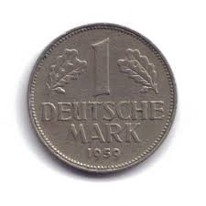

During World War II, the Soviet Union and the nations of the West had cooperated to defeat Nazi Germany. By 1945, however, the wartime alliance was crumbling. Conflicting ideologies (capitalism vs. communism) and mutual distrust divided the former Allies and soon led to a conflict called the Cold War. The Cold War was a state of tension and hostility among nations without armed conflict between the major rivals (USA and Soviet Union).
Stalin had two goals in eastern Europe. First he wanted to spread communism into that area. Second, he wanted to create a buffer zone of friendly nations as a defense against Germany, which had invaded Russia in both world War I and II.
Stalin and Truman saw Germany in a completely different light. Stalin wanted a weak Germany from which he took many reparations to rebuild his own country. For Truman, a strong Germany was important to rebuild Europe and to make it strong against the Soviet Union.
In June 1948 the Western Allies (USA, Britain, France) allowed the West Germans to work out their own democratic constitution for a West German state. In order to ensure a fast development of the economy the Western powers initiated a new currency, the Deutschmark, for the Western Zones, including West Berlin. In response to the Western Deutschmark and fearing a powerful Germany once again, Stalin also introduced a new currency in his zones, the East Mark, and more importantly, at midnight on the 23rd of June he started to blockade all road, canal and train traffic to West Berlin as well as the electricity supply from the East to the West.

“An Iron Curtain”

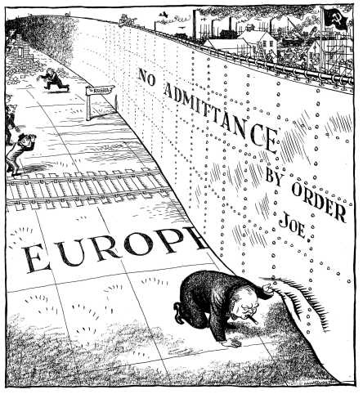

Less than a year after the end of World War II, the great wartime leader of Britain, Winston Churchill, delivered this speech in which he first coined the term "iron curtain" to describe the ominous postwar boundary in Europe between self-governing nations of the West and those in Eastern Europe which had recently come under the powerful grip of Soviet Russia.
During the war against Hitler, Russian troops had advanced far beyond their own borders into Europe, smashing Nazi Germany from the east while the Americans, British, Canadians and other allies attacked Hitler from the west. After the war, the Russians gave no indication they intended to withdraw and instead began installing puppet governments throughout Eastern Europe.
In this speech, Churchill begins by acknowledging America's newfound power in the world, and then offers a blunt assessment of the threat of Communism from Russia. Churchill gave the speech at Westminster College, in Fulton, Missouri, after receiving an honorary degree and was introduced by Missourian, President Harry Truman, who attended the event out of pure admiration for Churchill.
“A shadow has fallen upon the scenes so lately lighted by the Allied victory...From Stettin in the Baltic to Trieste in the Adriatic, an iron curtain has descended across the continent. Behind that line lie all the capitals of the ancient states of Central and Eastern Europe. Warsaw, Berlin, Prague, Vienna, Budapest, Belgrade, Bucharest and Sofia, all these famous cities and the populations around them lie in what I must call the Soviet sphere, and all are subject in one form or another, not only to Soviet influence but to a very high and, in some cases, increasing measure of control from Moscow.”
by Winston Churchill
The Truman Doctrine and Containment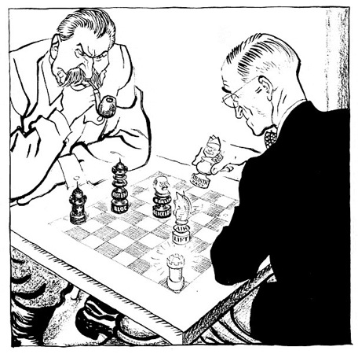

On Friday, February 21, 1947, the British Embassy informed the U.S. State Department officials that Great Britain could no longer provide financial aid to the governments of Greece and Turkey. American policymakers had been monitoring Greece's crumbling economic and political conditions, especially the rise of the Communist-led insurgency known as the National Liberation Front, or the EAM/ELAS. The United States had also been following events in Turkey, where a weak government faced Soviet pressure to share control of the strategic Dardanelle Straits. When Britain announced that it would withdraw aid to Greece and Turkey, the responsibility was passed on to the United States.
In a meeting between Congressmen and State Department officials, Undersecretary of State Dean Acheson articulated what would later become known as the domino theory. He stated that more was at stake than Greece and Turkey, for if those two key states should fall, communism would likely spread south to Iran and as far east as India. Acheson concluded that not since the days of Rome and Carthage had such a polarization of power existed. The stunned legislators agreed to endorse the program on the condition that President Truman stress the severity of the crisis in an address to Congress and in a radio broadcast to the American people.
Addressing a joint session of Congress on March 12, 1947, President Harry S. Truman asked for $400 million in military and economic assistance for Greece and Turkey and established a doctrine, aptly characterized as the Truman Doctrine, that would guide U.S. diplomacy for the next 40 years. President Truman declared, "It must be the policy of the United States to support free peoples who are resisting attempted subjugation by armed minorities or by outside pressures." The sanction of aid to Greece and Turkey by a Republican Congress indicated the beginning of a long and enduring bipartisan cold war foreign policy.
The Marshall Plan

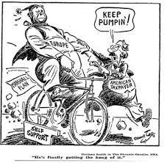

In the aftermath of WWII, Western Europe lay devastated. The war had ruined crop fields and destroyed infrastructure, leaving most of Europe in dire need. On June 5, 1947, Secretary of State GEORGE MARSHALL announced the European Recovery Program. To avoid antagonizing the Soviet Union, Marshall announced that the purpose of sending aid to Western Europe was completely humanitarian, and even offered aid to the communist states in the east. Congress approved Truman's request of $17 billion over four years to be sent to Great Britain, France, West Germany, Italy, the Netherlands and Belgium.
In a speech to Harvard University in 1947, Secretary of State George C. Marshall proposed that a post-war European aid program be initiated. Less than a year later, the Marshall Plan was a reality. The Marshall Plan funneled food and economic assistance to Europe to help rebuild countries. Billions in American aid helped war-shattered Europe recover rapidly and reduced communist influence there.
The MARSHALL PLAN created an economic miracle in Western Europe. By the target date of the program four years later, Western European industries were producing twice as much as they had been the year before war broke out. Some Americans grumbled about the costs, but the nation spent more on liquor during the years of the Marshall Plan than they sent overseas to Europe. The aid also produced record levels of trade with American firms, fueling a postwar economic boom in the United States.
Germany Divided

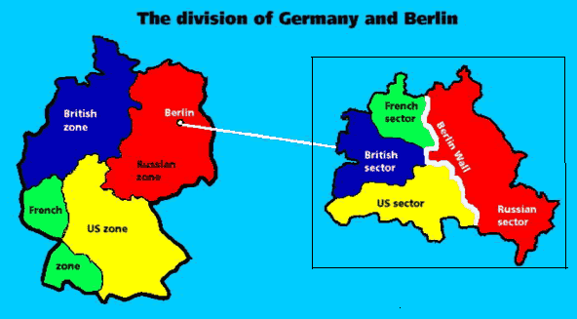

The separation of Berlin began in 1945 after the collapse of Germany. The country was divided into four zones, where each superpower controlled a zone. In 1946, reparation agreements broke down between the Soviet and Western zones. Response of the West was to merge French, British, and American zones in 1947.
The West wanted to revive the German economy and combine the three western zones into one area. The Soviet Union feared this union because it gave the one combined zone more power than its zone. On June 23, 1948, the western powers introduced a new form of currency into the western zones, which caused the Soviet Union to impose the Berlin Blockade one day later. After Germany was divided into two parts, East Germany built the Berlin Wall to prevent its citizens from fleeing to the west. The wall physically divided the country into eastern communism and western democracy. Many East Germans tried to escape to the west because it was economically prosperous and granted its citizens more freedoms.

The Berlin Airlift

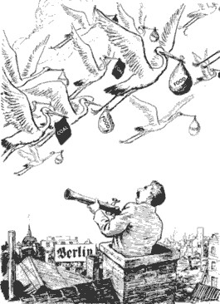

After World War II, the Allies partitioned the defeated Germany into a Soviet-occupied zone, an American-occupied zone, a British-occupied zone and a French-occupied zone. Berlin, the German capital city, was located deep in the Soviet zone, but it was also divided into four sections. In June 1948, the Russians–who wanted Berlin all for themselves–closed all highways, railroads and canals from western-occupied Germany into western-occupied Berlin. This, they believed, would make it impossible for the people who lived there to get food or any other supplies and would eventually drive Britain, France and the U.S. out of the city for good.
Instead of retreating from West Berlin, however, the U.S. and its allies decided to supply their sectors of the city from the air. The western powers responded to the blockade by mounting a round the clock airlift. For almost a year, cargo planes supplied West Berlin with food and fuel. The “Berlin Airlift,” carried more than 2.3 million tons of cargo into West Berlin.
The success of the airlift forced the Soviet Union to end the blockade. The West had won a victory in the Cold War, but the crisis deepened the hostility between the USA and Soviet Union.

NATO

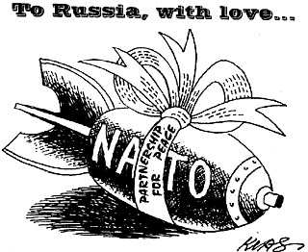
In 1949, the prospect of further Communist expansion prompted the United States and 11 other Western nations to form the North Atlantic Treaty Organization (NATO). The Soviet Union and its affiliated Communist nations in Eastern Europe founded a rival alliance, the Warsaw Pact, in 1955. The alignment of nearly every European nation into one of the two opposing camps formalized the political division of the European continent that had taken place since World War II (1939-45). This alignment provided the framework for the military standoff that continued throughout the Cold War (1945-91).
The discussions between the Western nations concluded on April 4, 1949, when the foreign ministers of 12 countries in North America and Western Europe gathered in Washington, D.C., to sign the North Atlantic Treaty. It was primarily a security pact, with Article 5 stating that a military attack against any of the signatories would be considered an attack against them all.
The original membership of the North Atlantic Treaty Organization (NATO) consisted of Belgium, Britain, Canada, Denmark, France, Iceland, Italy, Luxembourg, the Netherlands, Norway, Portugal and the United States. NATO formed the backbone of the West’s military bulwark against the USSR and its allies for the next 40 years, with its membership growing larger over the course of the Cold War era.

Warsaw Pact

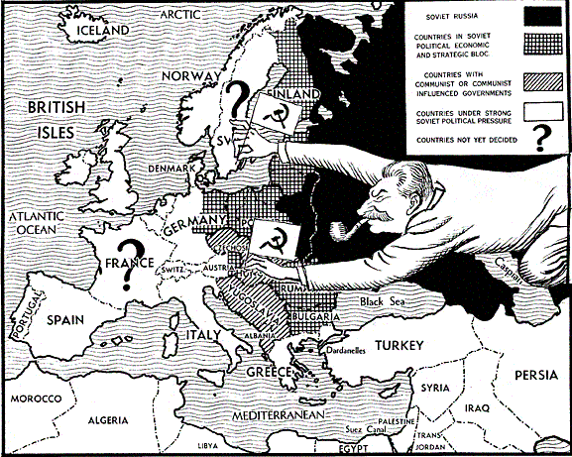

The Soviet Union and seven of its European satellites sign a treaty establishing the Warsaw Pact, a mutual defense organization that put the Soviets in command of the armed forces of the member states.
The Warsaw Pact, so named because the treaty was signed in Warsaw, included the Soviet Union, Albania, Poland, Romania, Hungary, East Germany, Czechoslovakia, and Bulgaria as members. The treaty called on the member states to come to the defense of any member attacked by an outside force and it set up a unified military command under Marshal Ivan S. Konev of the Soviet Union. The introduction to the treaty establishing the Warsaw Pact indicated the reason for its existence. This revolved around “Western Germany, which is being remilitarized, and her inclusion in the North Atlantic bloc, which increases the danger of a new war and creates a threat to the national security of peace-loving states.” This passage referred to the decision by the United States and the other members of the North Atlantic Treaty Organization (NATO) on May 9, 1955 to make West Germany a member of NATO and allow that nation to remilitarize. The Soviets obviously saw this as a direct threat and responded with the Warsaw Pact.

Arms Race

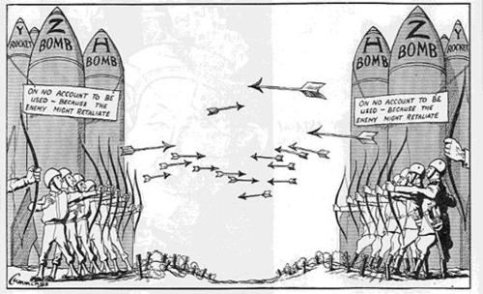

The nuclear arms race was central to the Cold War. Many feared where the Cold War was going with the belief that the more nuclear weapons you had, the more powerful you were. Both America and Russia massively built up their stockpiles of nuclear weapons.
The world greatly changed when USA exploded the H-bomb in 1952. This one bomb was smaller in size than the Hiroshima atomic bomb but 2500 times more powerful. The Russians produced an H-bomb in 1953 and the world became a much more dangerous place.
However, it is possible that the sheer power of these weapons and the fear that they evoked, may have stopped a nuclear war.
During the 1960’s the theory of MAD developed - Mutually Assured Destruction. This meant that if Russia attacked the west, the west would make sure that they would suitably retaliate i.e. there would be no winners.

