Lesson 1: To Kill a Mockingbird
Putting To Kill a Mockingbird in Context
In class, groups will read one article, answer the questions for the one article and then share with the rest of the class to fill in the attached chart and answer the question about life during the 1930s. All materials are in this document.

# 1 Harper Lee Biography
- A. How would you characterize, or describe, Harper Lee?
B. Provide three examples from the text to support your response.
# 2 jim Crow laws
- A. What seems to be the purpose of Jim Crow laws
B. Which of the sample laws provided stands out to you the most? Why?
# 3 Southern Women
- A. Based on the picture and quotations provided, how would you describe the “ideal” Southern girl?
B. How is the ideal Southern woman similar to expectations for girls and women today?
C. How is the ideal Southern woman different from expectations for girls and women today?

#4 Lynching
- A. What is lynching?
B. What is the “strange fruit” described in the poem? How do you know?

# 5 Great Depression
5. A. What effect does the description of the “strange fruit” in the poem have on you? Why?
B. What information presented in the text explains why the Great Depression was such a worldwide catastrophe?

# 6 Pictures of life from 1930s and 1940s.
6. A. What do the photographs suggest about what life was like for Americans during the Great Depression?
B. What do the text and photographs suggest about the emotions Americans faced each day during the Great Depression?
C. What inferences can you make about life in the 1930s based on these photographs?
D. Which photograph do you find most interesting? Why?

Life in the 1930s Adjective – after listening to the other groups, use the attached list of adjectives to describe life in the 1930s.

An adjective I would use to describe life in the 1930s would be ________________________________ because _______

__________________________________________________________________________________________________

_________________________________________________________________________________________________
#1 – Harper Lee Biography

Famed author Nelle Harper Lee was born on April 28, 1926, in Monroeville, Alabama. Lee is best known for writing the Pulitzer Prize-winning bestseller To Kill a Mockingbird (1960)—her one and only novel. The youngest of four children, she grew up as a tomboy in a small town. Her father was a lawyer, a member of the Alabama state legislature and also owned part of the local newspaper. For most of Lee's life, her mother suffered from mental illness, rarely leaving the house. It is believed that she may have had bipolar disorder.

One of her closest childhood friends was another writer-to-be, Truman Capote (then known as Truman Persons) . Tougher than many of the boys, Lee often stepped up to serve as Truman's protector. Truman, who shared few interests with boys his age, was picked on for being a sissy and for the fancy clothes he wore. While the two friends were very different, they both shared in having difficult home lives. Truman was living with his mother's relatives in town after

largely being abandoned by his own parents.

In high school, Lee developed an interest in English literature. After graduating in 1944, she went to the all-female Huntingdon College in Montgomery. Lee stood apart from the other students—she couldn't have cared less about fashion, makeup or dating. Instead, she focused on her studies and on her writing. Lee was a member of the literary honor society and the glee club.

Transferring to the University of Alabama at Tuscaloosa, Lee was known for being a loner and an individualist. She did make a greater attempt at a social life there, joining a sorority for a while. Pursuing her interest in writing, Lee contributed to the school's newspaper and its humor magazine, the Rammer Jammer. She eventually became the editor of the Rammer Jammer.

In her junior year, Lee was accepted into the university's law school, which allowed students to work on law degrees while still undergraduates. The demands of her law studies forced her to leave her post as editor of the Rammer Jammer. After her first year in the law program, Lee began expressing to her family that writing—not the law—was her true calling. She went to Oxford University in England that summer as an exchange student. Returning to her law studies that fall, Lee dropped out after the first semester. She soon moved to New York City to follow her dreams to become a writer.

In 1949, a 23-year-old Lee arrived in New York City. She struggled for several years, working as a ticket agent for Eastern Airlines and for the British Overseas Air Corp (BOAC). While in the city, Lee was reunited with old friend Truman Capote, one of the literary rising stars of the time.

She also befriended Broadway composer and lyricist Michael Martin Brown and his wife Joy.

In 1956, the Browns gave Lee an impressive Christmas present—to support her for a year so that she could write full time. She quit her job and devoted herself to her craft. The Browns also helped her find an agent, Maurice Crain. He, in turn, was able to get the publishing firm interested in her first novel, which was first titled Go Set a Watchman, then Atticus, and later To Kill a Mockingbird. Working with editor Tay Hohoff, Lee finished the manuscript in 1959.

Source: http://www.biography.com/people/harper-lee-9377021?page=1

#2 – Jim Crow Laws

From the 1880s into the 1960s, a majority of American states enforced segregation through "Jim Crow" laws (so called after a black character in minstrel shows). From Delaware to California, and from North Dakota to Texas, many states (and cities, too) could impose legal punishments on people for consorting with members of another race. The most common types of laws forbade intermarriage and ordered business owners and public institutions to keep their black and white clientele separated. Here is a sampling of laws from various states:

Nurses No person or corporation shall require any white female nurse to nurse in wards or rooms in hospitals, either public or private, in which negro men are placed. Alabama

Buses All passenger stations in this state operated by any motor transportation company shall have separate waiting rooms or space and separate ticket windows for the white and colored races. Alabama

Restaurants It shall be unlawful to conduct a restaurant or other place for the serving of food in the city, at which white and colored people are served in the same room, unless such white and colored persons are effectually separated by a solid partition extending from the floor upward to a distance of seven feet or higher, and unless a separate entrance from the street is provided for each compartment. Alabama

Toilet Facilities, Male Every employer of white or negro males shall provide for such white or negro males reasonably accessible and separate toilet facilities. Alabama

Intermarriage It shall be unlawful for a white person to marry anyone except a white person. Any marriage in violation of this section shall be void. Georgia

Burial The officer in charge shall not bury, or allow to be buried, any colored persons upon ground set apart or used for the burial of white persons. Georgia

Amateur Baseball It shall be unlawful for any amateur white baseball team to play baseball on any vacant lot or baseball diamond within two blocks of a playground devoted to the Negro race, and it shall be unlawful for any amateur colored baseball team to play baseball in any vacant lot or baseball diamond within two blocks of any playground devoted to the white race. Georgia

Parks It shall be unlawful for colored people to frequent any park owned or maintained by the city for the benefit, use and enjoyment of white persons . . . and unlawful for any white person to frequent any park owned or maintained by the city for the use and benefit of colored persons. Georgia

Circus Tickets All circuses, shows, and tent exhibitions, to which the attendance of . . . more than one race is invited or expected to attend shall provide for the convenience of its patrons not less than two ticket offices with individual ticket sellers, and not less than two entrances to the said performance, with individual ticket takers and receivers, and in the case of outside or tent performances, the said ticket offices shall not be less than twenty-five (25) feet apart. Louisiana

The Blind The board of trustees shall . . . maintain a separate building . . . on separate ground for the admission, care, instruction, and support of all blind persons of the colored or black race. Louisiana

Promotion of Equality Any person . . . who shall be guilty of printing, publishing or circulating printed, typewritten or written matter urging or presenting for public acceptance or general information, arguments or suggestions in favor of social equality or of intermarriage between whites and negroes, shall be guilty of a misdemeanor and subject to fine or not exceeding five hundred (500.00) dollars or imprisonment not exceeding six (6) months or both. Mississippi

Prisons The warden shall see that the white convicts shall have separate apartments for both eating and sleeping from the negro convicts. Mississippi

Education Separate free schools shall be established for the education of children of African descent; and it shall be unlawful for any colored child to attend any white school, or any white child to attend a colored school. Missouri

Textbooks Books shall not be interchangeable between the white and colored schools, but shall continue to be used by the race first using them. North Carolina

Source: http://academic.udayton.edu/race/02rights/jcrow02.htm

#3 – Southern Women

Left: A perfect picture of the proper little girl and the ideal family in the South in the 1930s. Photo courtesy of Mary Ann Norton Meredith
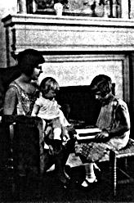

“We must persistently strive against selfishness, ill-temper, irritability, indolence. It is impossible for the self-centered or ill-tempered girl to win love and friends.

One of the greatest blemishes in the character of any young person, especially of any young girl or woman, is forwardness, boldness, pertness. The young girl who acts in such a manner as to attract attention in public; who speaks loudly, and jokes and laughs and tells stories in order to be heard by others than her immediate companions, . . . who expresses opinions on all subjects with forward self-confidence, is rightly regarded by all thoughtful and cultivated people as one of the most disagreeable and obnoxious characters to be met with in society.”

--Helen Ekin Starrett, The Charm of Fine Manners (1920)

Source: http://library.thinkquest.org/12111/girl.html
“Southern Belles and Ladies”

A southern belle was a girl who was expected to grow up into a lady. She was supposed to be fragile and flirtatious while also sexually innocent. She was beautiful but risky to touch, like porcelain. Every southern belle was expected to be up-to-date on the latest fashions, which often proved tricky and expensive because fashion was constantly changing throughout the nineteenth century. A true lady embodied the ideals of the South, and was thus hospitable and graceful. Newspapers often took it upon themselves to update their lady readers on the newest fashion trends. The Natchez

Weekly Democrat reported on November 22, 1873, that lady readers will be interested to know that spotted short veils are no longer fashionable. Bracelets are now made to twine around the arm and require no clasp. In the new style of hairdressing, called the Josephine, chignons are entirely abolished. The hair is drawn up from the back of the head and piled on the top in thick coils or braids, and loosely frizzled in front.

Source: http://historyengine.richmond.edu/episodes/view/2259

#4 – Lynching

“Lynching is the practice whereby a mob – usually several dozen or several hundred persons – takes the law into its own hands in order to injure and kill a person accused of some wrongdoing. The alleged offense can range from a serious crime like theft or murder to a mere violation of local customs and sensibilities. The issue of the victim's guilt is usually secondary, since the mob serves as prosecutor, judge, jury, and executioner.”

--Robert L. Zangrando, “About Lynching”
Source: http://www.english.illinois.edu/maps/poets/g_l/lynching/lynching.htm

Strange Fruit
Abel Meeropol (1937); Recorded as a song by Billie Holiday in 1939
Southern trees bear a strange fruit,

Blood on the leaves and blood at the root,

Black bodies swinging in the southern breeze,

Strange fruit hanging from the poplar trees.

Pastoral scene of the gallant south,

The bulging eyes and the twisted mouth,

Scent of magnolias, sweet and fresh,

Then the sudden smell of burning flesh.

Here is fruit for the crows to pluck,

For the rain to gather, for the wind to suck,

For the sun to rot, for the trees to drop,

Here is a strange and bitter crop.
Source: http://www.lyricsfreak.com/b/billie+holiday/strange+fruit_20017859.html

#5 – The Great Depression

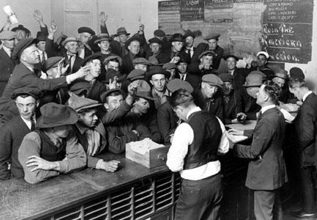
Figure 1: Unemployed men vying for jobs at the American Legion Employment Bureau in Los Angeles during the Great Depression

The 1929 stock market crash set into motion a series of events that plunged America into its greatest economic depression. By 1933, the country’s gross national product had been nearly cut in half, and 16 million Americans were unemployed. Not until 1937 did the New Deal policies of President Franklin Roosevelt temper the catastrophe. This economic downturn persisted until the massive investment in national defense demanded by World War II.

The causes of the Depression were many, and still debated. High spending in the 1920s created a gap preventing working class people from increasing their incomes. The trade policies of earlier administrations increased the cost of American goods abroad. Lines of credit were overextended, which fueled speculation on Wall Street. The crash that occurred on October 29, 1929 (“Black Tuesday”) soon spread across the world, ruining European economies not fully recovered from WW1

American writers and artists depicted the devastation in prose and pictures. John Steinbeck immortalized the plight of Oklahoma tenant farmers fleeing the Dust Bowl in The Grapes of Wrath (1939). James Agee’s Let Us Now Praise Famous Men (1941) used the grim but dignified photographs of Walker Evans to illustrate the catastrophe in rural areas. Photographer Dorothea Lange, employed by the Farm
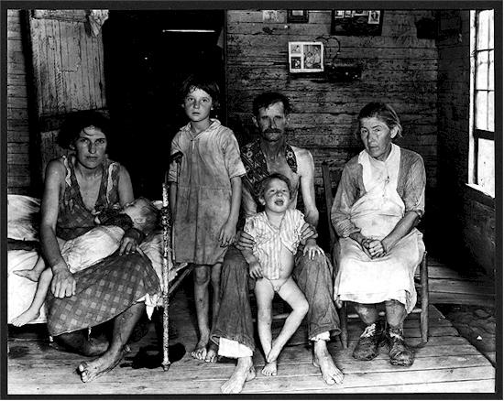
Security Administration, documented in magazines and newspapers nationwide the reality that confronted American farmers.

Harper Lee experienced the Great Depression as a child in Monroeville, Alabama, and used her memory of it in To Kill a Mockingbird. “Maycomb County,” she writes, “had recently been told that it had nothing to fear but fear itself,” a reference to a famous speech by President Roosevelt. Walter Cunningham’s father refused a WPA (Works Progress
Administration) job, fearing what would come of his independence if he went on relief. And Bob Ewell, as Scout tells us, was “the only man I ever heard of who was fired from the WPA for laziness.”
: Dorothea Lange's "Migrant Mother," destitute in a pea picker's camp, because of the failure of the early pea crop. These people had just sold their tent in order to buy food. Most of the 2,500 people in this camp were destitute. By the end of the decade there were still 4 million migrants on the road.
Text Source: http://www.neabigread.org/teachers_guides/handouts/mockingbird/mockingbirdhandout02.pdf
Photo Source: http://www.english.illinois.edu/maps/depression/photoessay.htm

#6 – Life in the 1930s and 1940s

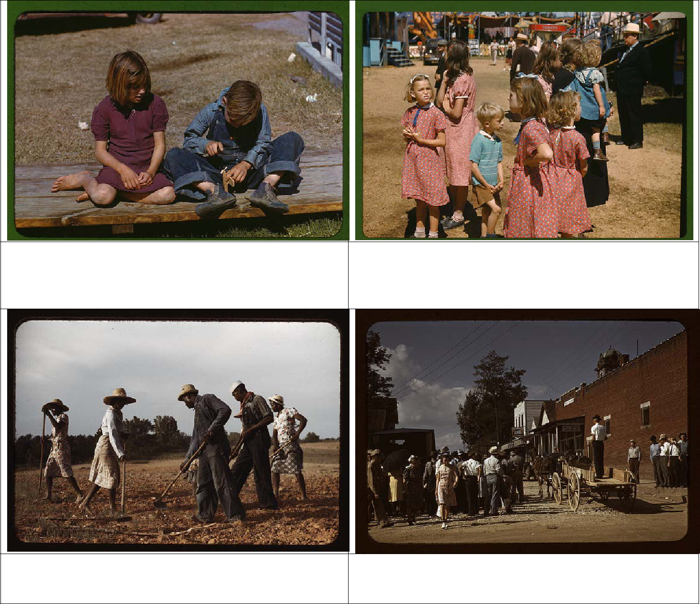

A boy builds a model airplane as a girl watches in a Farm Security Administration Camp in Robstown, Texas in January 1942.

Boys and girls at the Rutland State Fair in Rutland, Vermont in September 1941.

Chopping cotton on rented land in White Plains, near Greene County, Georgia in June 1941.

Farmers and townspeople in the center of town on Court day in Campton, Kentucky in September 1940.

Source: http://www.flickr.com/photos/library_of_congress/sets/72157603671370361/with/2178246047

List of Adjectives
→Remember that adjectives describe or indicaate the degree of nouns or pronouns. Also, they are occasionally used after linking verbs.

abrupt | corny | filthy | juicy | precious | sticky
acidic | costly | flat | jumpy | prickly | stormy
adorable | courageous | floppy | kind | proud | stout
adventurous | crabby | fluttering | lackadaisical | pungent | straight
aggressive | creepy | foolish | large | puny | strange
agitated | crooked | frantic | lazy | quaint | strong
alert | cruel | fresh | lethal | quizzical | stunning
aloof | cumbersome | friendly | little | ratty | substantial
amiable | curved | frightened | lively | reassured | successful
amused | cynical | frothy | livid | relieved | succulent
annoyed | dangerous | frustrating | lonely | repulsive | superficial
antsy | dashing | funny | loose | responsive | superior
anxious | decayed | fuzzy | lovely | ripe | swanky
appalling | deceitful | gaudy | lucky | robust | sweet
appetizing | deep | gentle | ludicrous | rotten | tart
apprehensive | defeated | ghastly | macho | rotund | tasty
arrogant | defiant | giddy | magnificent | rough | teeny
ashamed | delicious | gigantic | mammoth | round | tender
astonishing | delightful | glamorous | maniacal | salty | tense
attractive | depraved | gleaming | massive | sarcastic | terrible
average | depressed | glorious | melancholy | scant | testy
batty | despicable | gorgeous | melted | scary | thankful
beefy | determined | graceful | miniature | scattered | thick
bewildered | dilapidated | greasy | minute | scrawny | thoughtful
biting | diminutive | grieving | mistaken | selfish | thoughtless
bitter | disgusted | gritty | misty | shaggy | tight
bland | distinct | grotesque | moody | shaky | timely
blushing | distraught | grubby | mortified | shallow | tricky
bored | distressed | grumpy | motionless | sharp | trite
brave | disturbed | handsome | muddy | shiny | troubled
bright | dizzy | happy | mysterious | short | twitter pated
broad | drab | harebrained | narrow | silky | uneven
bulky | drained | healthy | nasty | silly | unsightly
burly | dull | helpful | naughty | skinny | upset
charming | eager | helpless | nervous | slimy | uptight
cheeky | ecstatic | high | nonchalant | slippery | vast
cheerful | elated | hollow | nonsensical | small | vexed
chubby | elegant | homely | nutritious | smarmy | victorious
clean | emaciated | horrific | nutty | smiling | virtuous
clear | embarrassed | huge | obedient | smoggy | vivacious
cloudy | enchanting | hungry | oblivious | smooth | vivid
clueless | encouraging | hurt | obnoxious | smug | wacky
clumsy | energetic | icy | odd | soggy | weary
colorful | enormous | ideal | old-fashioned | solid | whimsical
colossal | enthusiastic | immense | outrageous | sore | whopping
combative | envious | impressionable | panicky | sour | wicked
comfortable | exasperated | intrigued | perfect | sparkling | witty
condemned | excited | irate | perplexed | spicy | wobbly
condescending | exhilarated | irritable | petite | splendid | wonderful
confused | extensive | itchy | petty | spotless | worried
contemplative | exuberant | jealous | plain | square | yummy
convincing | fancy | jittery | pleasant | stale | zany
convoluted | fantastic | jolly | poised | steady | zealous
cooperative | fierce | joyous | pompous | steep | zippy

