ENDURING ISSUE ESSAY
This question is based on the accompanying documents. The question is designed to test your ability to work with historical documents. Some of these documents have been edited for the purposes of this question. As you analyze the documents, take into account the source of each document and any point of view that may be presented in the document. Keep in mind that the language used in a document may reflect the historical context of the time in which it was written.

An enduring issue is a challenge or problem that has been debated or discussed across time. An enduring issue is one that many societies have attempted to address with varying degrees of success.
Task:
• Identify and define an enduring issue raised by this set of documents
• Using your knowledge of social studies and evidence from the documents, argue why the issue you selected is significant and how it has endured across time

In developing your answers to Part III, be sure to keep these explanations in mind: Identify – means to put a name to; to name. Define – means to explain features of a thing or concept so that it can be understood. Argue – means to provide a series of statements that provide evidence and reasons to support a conclusion.
Guidelines: In your essay, be sure to • Identify the enduring issue based on a historically accurate interpretation of at least three documents. • Define the issue using evidence from at least three documents • Argue that this is a significant issue that has endured by showing: – How the issue has affected people or has been affected by people – How the issue has continued to be an issue or has changed over time • Include outside information from your knowledge of social studies and include evidence from the documents

9/11 Enduring Issues 9/2019

Document 1
Chart of Incidents of Terrorism and Deaths and Injuries from Terroristic Acts since 1970

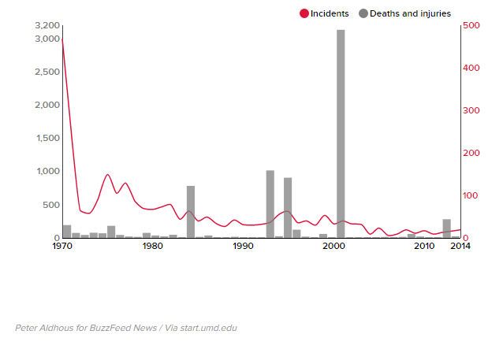

Incidents are represented by the line
Deaths and injuries are represented by the bars

Document 2

02/26/08
Part 2 of our history series commemorating the FBI’s 100th anniversary in 2008.

Fifteen years ago this week, at about 17 minutes past noon, a thunderous explosion rocked lower Manhattan.
The epicenter was the parking garage beneath the World Trade Center, where a massive eruption carved out a nearly 100-foot crater several stories deep and several more high. Six people were killed almost instantly. Smoke and flames began filling the wound and streaming upward into the building. Those who weren’t trapped were soon pouring out of the building—many panic-stricken and covered in soot. More than a thousand people were hurt in some way, some badly, with crushed limbs.
It was Friday, February 26, 1993, and Middle Eastern terrorism had arrived on American soil—with a bang.

Document 3

April 18, 2019

FBI Oklahoma City Field Office Observes 24th Anniversary of Oklahoma City Bombing
OKLAHOMA CITY—On April 19, 2019, members of the Federal Bureau of Investigation Oklahoma City Field Office participated in several remembrance ceremonies marking the 24th anniversary of the Oklahoma City Bombing.
On the morning of April 19, 1995, Timothy McVeigh parked a rented Ryder truck in front of the Alfred P. Murrah Federal Building in downtown Oklahoma City, Oklahoma, and detonated a self-assembled bomb. This act of homegrown terrorism claimed the lives of 168 innocent individuals, including 19 children, leaving several hundred more injured.
During a remembrance ceremony held at the FBI Oklahoma City Field Office, employees observed 168 seconds of silence at precisely 9:02 a.m., the moment the bomb exploded.
Special Agent in Charge Kathryn Peterson honored the service of current FBI employees for their actions as first responders in the aftermath of the bombing.
Leadership of the FBI Oklahoma City Field Office attended a remembrance ceremony at the Oklahoma City National Memorial & Museum alongside survivors, families of victims, first responders, and dignitaries. Speakers addressed the actions of law enforcement partners following the bombing as well an outpouring of generosity by the state’s residents following the tragic events, which has since become known as the ‘Oklahoma Standard'.
The FBI, its Joint Terrorism Task Forces, and the thousands of individuals across the Bureau remain dedicated to combating and dismantling acts of terrorism both domestically and internationally.
FBI Oklahoma City
Public Affairs Specialist/Media Coordinator Andrea Anderson
(405) 290-3992

Document 4

NOTE: This report is an unclassified summary of a 168-page classified report that was also issued today, 10 April 2014, by the Inspectors General for the Intelligence Community, Central Intelligence Agency, Department of Justice, and Department of Homeland Security. Redactions in this document are the result of classification and sensitivity designations we received from agencies and departments that provided information to the OIGs for this review. As to several of these classification and sensitivity designations, the OIGs disagreed with the bases asserted. We are requesting that the relevant entities reconsider those designations so that we can unredact those portions and make this information available to the public.

I. INTRODUCTION On April 15, 2013, two pressure cooker bombs placed near the finish line of the Boston Marathon detonated within seconds of each other, killing three and injuring more than two hundred people. Law enforcement officials identified brothers Tamerlan and Dzhokhar Tsarnaev as primary suspects in the bombings. After an extensive search for the thenunidentified suspects, law enforcement officials encountered Tamerlan and Dzhokhar Tsarnaev in Watertown, Massachusetts. Tamerlan Tsarnaev was shot during the encounter and was pronounced dead shortly thereafter. Dzhokhar Tsarnaev, who fled the scene, was apprehended the following day and remains in federal custody.

