Priority Standards
10.5 UNRESOLVED GLOBAL CONFLICT (1914–1945): World War I and World War II led to geopolitical changes, human and environmental devastation, and attempts to bring stability and peace.
(Standards: 2, 3, 4, 5; Themes: TCC, GEO, GOV, CIV, TECH, EXCH)
10.5d Nationalism and ideology played a significant role in shaping the period between the world wars.
- Students will examine the role of nationalism and militarism in Japan.

LEARNING TARGET: I can investigate Japan’s role in World War II to determine if the atomic bombing of Hiroshima and Nagasaki were justified.
TASKS:
- This activity is divided into five parts and should take about 90 minutes
- Part I: Rape of Nanjing
Part II: Pearl Harbor
Part III: Iwo Jima
Part IV: Atomic War
Part V: TEES Paragraph
- Follow the links and answer the questions

Part I: Rape of Nanjing
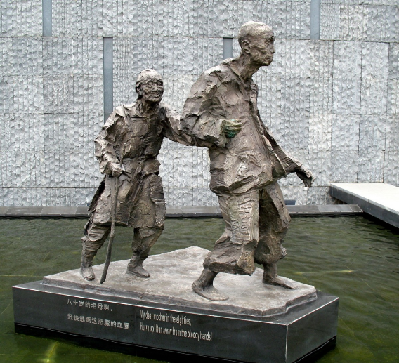
Watch this video https://www.facinghistory.org/resource-library/video/nanjing-atrocities-crimes-war
- Who is Chiang Kai-shek?

- Why did the Japanese promote Pan-Asianism?

- Why did the Chinese resist Pan-Asianism?

- Research on your own to discover how many Chinese were raped and murdered during the massacre:

Part II: Pearl Harbor
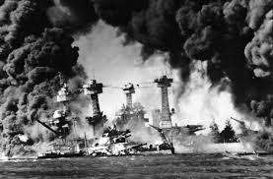
Just before 8 a.m. on December 7, 1941, hundreds of Japanese fighter planes attacked the American naval base at Pearl Harbor near Honolulu, Hawaii. The barrage lasted just two hours, but it was devastating: The Japanese managed to destroy nearly 20 American naval vessels, including eight enormous battleships, and almost 200 airplanes. More than 2,000 Americans soldiers and sailors died in the attack, and another 1,000 were wounded. The day after the assault, President Franklin D. Roosevelt asked Congress to declare war on Japan; Congress approved his declaration with just one dissenting vote. Three days later, Japanese allies Germany and Italy also declared war on the United States, and again Congress reciprocated. More than two years into the conflict, America had finally joined World War II.
Watch the News Report: https://www.youtube.com/watch?v=A2kSnlS4xX8
What is the POV of the New Reporter regarding the attack on Pearl Harbor
Why do you think the Japanese bombed Pearl Harbor? Explain.

Watch the Hollywood Movie: https://www.youtube.com/watch?v=Sv1niwxQgoY

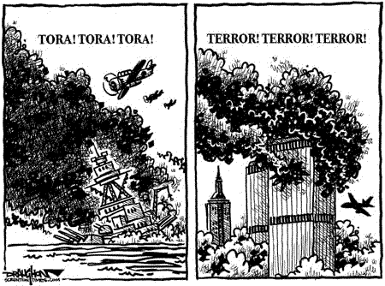
Identify the two events depicted in this cartoon
What is the cartoonist’s POV

Part III: Iwo Jima
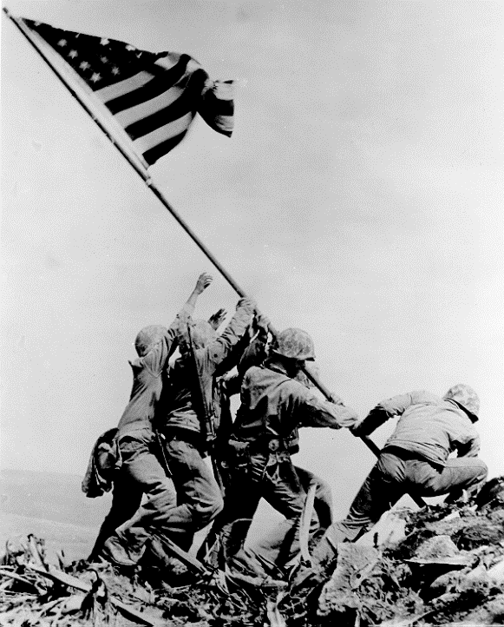
The American amphibious invasion of Iwo Jima during World War II stemmed from the need for a base near the Japanese coast. Following elaborate preparatory air and naval bombardment, three U.S. marine divisions landed on the island in February 1945. Iwo Jima was defended by roughly 23,000 Japanese army and navy troops, who fought from an elaborate network of caves, dugouts, tunnels and underground installations. Despite the difficulty of the conditions, the marines wiped out the defending forces after a month of fighting, and the battle earned a place in American lore with the publication of a photograph showing the U.S. flag being raised in victory.
https://www.youtube.com/watch?v=8rfsRNeiing
Why was the island of Iwo Jima important to USA military plans?
What lesson did the USA learn from the battle for Iwo Jima?

Part IV: Atomic War
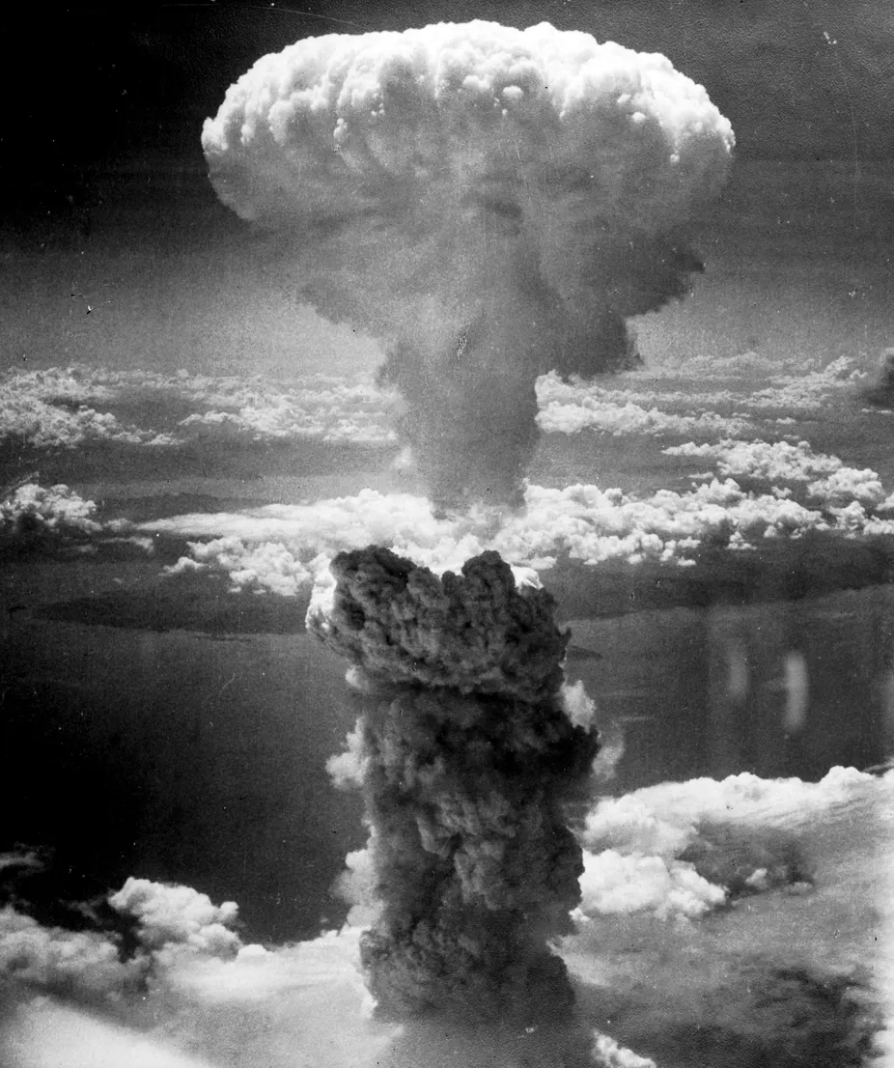
Watch the video: https://www.youtube.com/watch?v=2Pxk4zy_SQw

Poems by Toge Sankichi: Hibakusha (A‐bomb survivor)
Toge Sankichi was born in Japan in 1917. He started writing poems at the age of eighteen. He was twenty-eight when the A-bomb was dropped on Hiroshima on 6 August 1945. He died at age thirty-six, a victim of leukemia resulting from the A-bomb. His first hand experience of the bomb, his passion for peace and his realistic insight into the event made him the leading Hiroshima poet in Japan.
August 6
How could I ever forget that flash of light!
In a moment thirty thousand people ceased to be
The cries of fifty thousand killed
Through yellow smoke whirling into light
Buildings split, bridges collapsed
Crowded trams burnt as they rolled about
Hiroshima, all full of boundless heaps of embers
Soon after, skin dangling like rags
With hands on breasts
Treading upon the spilt brains
Wearing shreds of burnt cloth round their loins
There came numberless lines of the naked
all crying
Bodies on the parade ground, scattered like
jumbled stone images
Crowds in piles by the river banks
loaded upon rafts fastened to shore
Turned by and by into corpses
under the scorching sun
in the midst of flame
tossing against the evening sky
Round about the street where mother and
brother were trapped alive under the fallen house
The fire-flood shifted on
On beds of filth along the
Armory floor Heaps, God knew who they were....
Heaps of schoolgirls lying in refuse
Pot-bellied, one-eyed
with half their skin peeled off, bald
The sun shone, and nothing moved
but the buzzing flies in the metal basins
Reeking with stagnant odor
How can I forget that stillness
Prevailing over the city of three hundred thousand?
Amidst that calm
How can I forget the entreaties
Of the departed wife and child
Through their orbs of eyes
Cutting through our minds and souls?

At the First-Aid Station
You
Who weep although you have no ducts for tears
Who cry although you have no lips for words
Who wish to clasp
Although you have no skin to touch
You
Limbs twitching, oozing blood and foul secretions
Eyes all puffed-up slits of white
Tatters of underwear
Your only clothing now
Yet with no thought of shame
Ah! How fresh and lovely you all were
A flash of time ago
When you were school girls, a flash ago
Who could believe it now?
Out from the murky, quivering flames
Of burning, festering Hiroshima
You step, unrecognizable even to yourselves
You leap and crawl, one by one
Onto this grassy plot
Wisps of hair on bronze bald heads Into the dust of agony
Why have you had to suffer this?
Why this, the cruelest of inflictions?
Was there some purpose?
Why?
You look so monstrous, but could not know
How far removed you are now from mankind
You think: Perhaps you think
Of mothers and fathers, brothers and sisters
Could even they know you now?
Of sleeping and waking, of breakfast and home
Where the flowers in the hedge scattered in a flash
And even the ashes now have gone
Thinking, thinking, you are thinking
Trapped with friends who ceased to move, one by one
Thinking when once you were a daughter
A daughter of humanity

At the First-Aid Station & August 6th by Toge Sankicki
What is the setting of the poems?
Why do you think Sankicki emphasizes the suffering of the school girls? Explain.
Describe the mood of the poems.
What does Sankicki want from the children of Hiroshima? Explain.
What is the author’s tone? What is he saying about war?
What is Sankicki’s POV about atomic warfare?

General Paul Tibbets
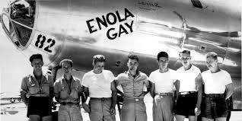
The Enola Gay was the B-29 bomber that was used by the United States on August 6, 1945, to drop an atomic bomb on Hiroshima, Japan, the first time the explosive device had been used on an enemy target. The aircraft was named after the mother of pilot Paul Warfield Tibbets, Jr.
Watch 5 minutes of the interview with General Paul Tibbets here: https://www.manhattanprojectvoices.org/oral-histories/general-paul-tibbets-%E2%80%93-reflections-hiroshima

List 3 reasons to support using the atomic bombs | List 3 reasons against using the atomic bombs

Part V: TEES Paragraph
TEES: Some historians believe that the atomic bombing of Hiroshima and Nagasaki was necessary. Do you agree with this the? Why or why not?

T  Thesis | E  Explain | E  Evidence | S  Summary
-Identifies the argument or main point  -Establishes a controlling idea, which makes a specific comment about a topic | -Specifies and narrows the topic sentence  -Clarifies the topic by describing in more detail and/or revealing relevant facts | -Support with specific information from the text or lesson  -Select appropriate historical information to support thesis | -Summarizes the main point(s)  -States the paragraph’s main conclusion, purpose, or idea
1 POINT | 1 POINT | 2 POINTS | 1 POINT

