D-Day
Link to Ernie Pyle’s “The Horrible Waste of War” https://sites.mediaschool.indiana.edu/erniepyle/1944/06/16/the-horrible-waste-of-war/

1. As Ernie Pyle walks along the beaches of Normandy, France he describes
- a beautiful day at the beach
- the glory of war
- the allied retreat across the English Channel
- the horrors of war and the cost of victory
2. What does Ernie Pyle mean when he says, “Men were sleeping on the sand, some of them sleeping forever.”
- Many soldiers were tired from the battle and were resting
- Many soldiers were tired from moving the machinery and were resting
- Many soldiers were injured and were dead
- Soldiers were relaxing on the beach
3. What is ironic about the 4-leafed clover on the backs of the jellyfish?
- Many soldiers survived because they had good luck
- Luck does not matter in war
- Many men died despite the good luck symbol
- The jellyfish survived
4. What does Ernie Pyle mean when he says, “on the beach lay expended, sufficient men…”
- Many soldiers died
- More soldiers died than were necessary
- The death of an individual soldier is insignificant in war
- Soldiers are not important in war
5. What is the dog doing on the beach?
- Begging for food
- Waiting to get on a boat
- Looking for his master
- Looking for another dog
6. The imagery Ernie Pyle’s “Brave Men” focuses on
- the individual soldier
- details of his own experiences
- the financial cost of war
- the total cost of war
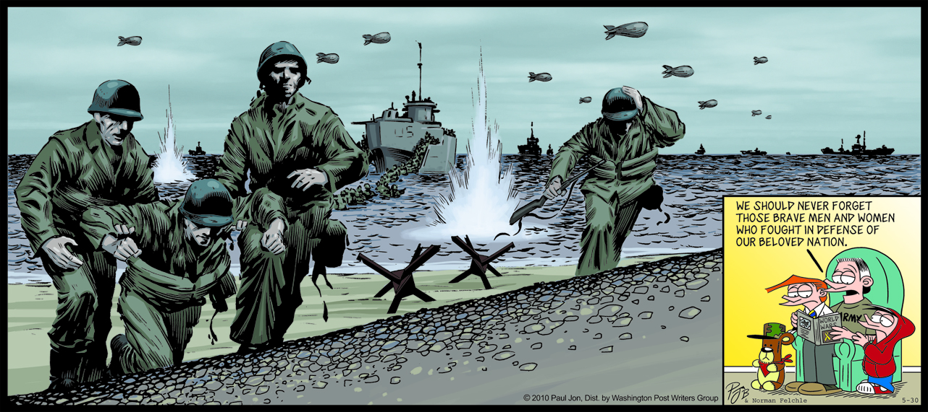

What historic event does the cartoon depict?
What is the cartoonist’s POV?

“Silent Guns” by Anthony Dannible

I sit in the comfort
Of my house and my
Thoughts go back to the
Beach.

The shock and shell are
Just a memory.

We laid to rest our
closest friends and
Friends we didn’t know

We passed people on the street
and they said “God
Bless you” but no more
Over there they still say “God
Bless you”

I think of those that
Didn’t come back and how
some will be missed and
I think of their children
that will never be born.
I know God will keep them
Safe.

I think of my children
and wonder if they will
think it was worth it

Who is the poet’s intended audience?

D-Day

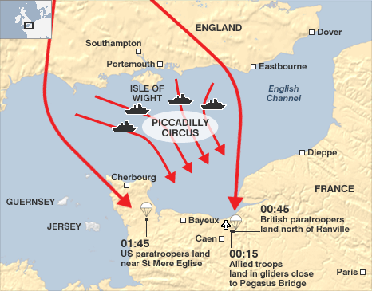
On June 6, 1944 the Allied Forces of Britain, America, Canada, and France attacked German forces on the coast of Normandy, France. With a huge force of over 150,000 soldiers, the Allies attacked and gained a victory that became the turning point for World War II in Europe. This famous battle is sometimes called D-Day or the Invasion of Normandy
Germany had invaded France and was trying to take over all of Europe including Britain. However, Britain and the United States had managed to slow down the expanding German forces. They were now able to turn on the offensive.
To prepare for the invasion, the Allies amassed troops and equipment in Britain. They also increased the number of air strikes and bombings in German territory. Right before the invasion, over 1000 bombers a day were hitting German targets. They bombed railroads, bridges, airfields, and other strategic places in order to slow down and hinder the German army.
The first wave of the attack began with the paratroopers. These were men who jumped out of planes using parachutes. They jumped at night in the pitch dark and landed behind enemy lines. Their job was to destroy key targets and capture bridges in order for the main invasion force to land on the beach. Thousands of dummies were also dropped in order to draw fire and confuse the enemy.
In the next stage of the battle thousands of planes dropped bombs on German defenses. Soon after, warships began to bomb the beaches from the water. While the bombing was going on, underground members of the French Resistance sabotaged the Germans by cutting telephone lines and destroying railroads.
Soon the main invasion force of over 6,000 ships carrying troops, weapons, tanks, and equipment approached the beaches of Normandy.
American troops landed at Omaha and Utah beaches. The Utah landing was successful, but the fighting at Omaha beach was fierce. Many US soldiers lost their lives at Omaha, but they were finally able to take the beach.
By the end of D-Day over 150,000 troops had landed in Normandy. They pushed their way inland allowing more troops to land over the next several days. By June 17th over half a million Allied troops had arrived and they began to push the Germans out of France.
D-Day was the beginning of the end for not only the Germans but Hitler most of all. D-Day forced the Germans to fight a two front war again just as they had in WWI. Yet again the Germans could not handle war on both sides of them.
TEES: Some historians believe D-Day was the turning point of WWII. Support, refute, or modify this thesis.

T  Thesis | E  Explain | E  Evidence | S  Summary
-Identifies the argument or main point  -Establishes a controlling idea, which makes a specific comment about a topic | -Specifies and narrows the topic sentence  -Clarifies by describing in more detail and/or revealing relevant facts | -Support with specific information from the text or lesson  -Select appropriate historical information to support thesis | -Summarizes the main point(s)  -States the paragraph’s main conclusion, purpose, or idea
1 POINT | 1 POINT | 2 POINTS | 1 POINT

