WWII: Russia’s Role

Joseph Stalin disregarded early warnings of the German attack.
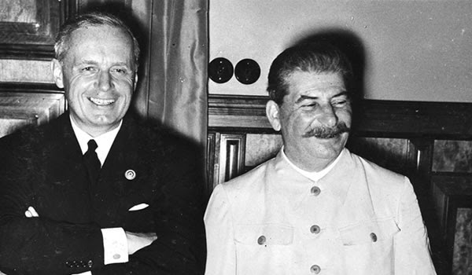
Joseph Stalin and German Foreign Minister Joachim von Ribbentrop at signing of Soviet-German non-aggression pact in 1939.

Germany’s invasion of Russia was the largest surprise attack in military history, but according to most sources, it shouldn’t have come as a surprise at all. While the Soviet Union and Nazi Germany had signed a famous non-aggression pact in August 1939, many anticipated that Adolf Hitler had designs on attacking the Russians—whom he viewed as an inferior race—as soon as the time was right. Nevertheless, Stalin appeared blind to the Nazi leader’s true intentions. In the months before the German advance, he brushed off dozens of reports from Soviet spies warning that an invasion was imminent. He also accepted Hitler’s cover story that the sudden presence of German troops on the Soviet border was merely a move to keep them out of range of British bomb strikes, and even ordered his troops to not fire on German spy planes despite numerous “accidental” invasions of Soviet airspace. Stalin’s puzzling trust in the Third Reich was finally dashed on June 22, 1941, when the Germans launched Operation Barbarossa and invaded the Soviet Union with more than three million men.

2. Most people believed Germany would quickly crush the Soviet Union.
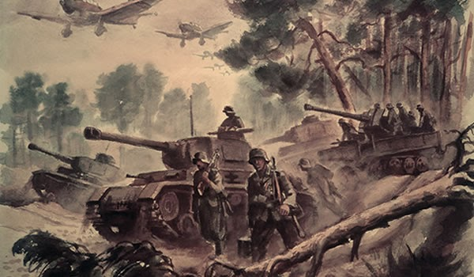
Operation Barbarossa was intended to deal a total defeat to the Soviets in only three to six months, but in the early days of the invasion, many thought the fall might come even sooner. German troops killed or wounded 150,000 Soviets in the first week of the campaign, while the Luftwaffe—the Nazi air force—destroyed over 2,000 Russian planes in just the first two days. As German tanks and troops swarmed through Soviet territory in a three-pronged attack, most outside analysts began predicting that a Russian defeat was only weeks or even days away. Despite these early setbacks, the Soviets’ seemingly inexhaustible supply of troops ultimately proved too much for the Germans to overcome. While the invaders succeeded in knocking several million Russian soldiers out of the war by November 1941, they had also suffered more than 700,000 casualties of their own. Following a series of ferocious counterattacks by the Soviets, the Nazis were forced to abandon all hope of a swift victory. The war would drag on for another three and a half years.

3. Extreme weather conditions played a crucial role in the Soviet victory.
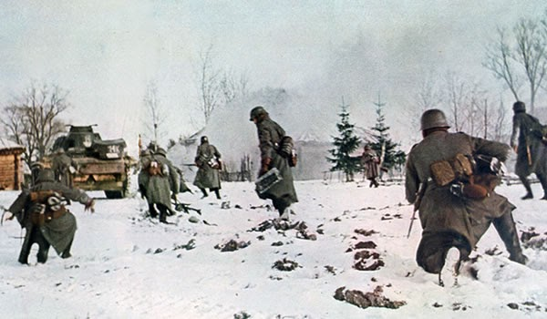
In addition to the might of the Red Army, German troops were also worn down by “General Winter”—the nickname used to describe the deadly Russian frost. Adolf Hitler’s invasion plans called for the Germans to conquer the Soviet Union before the legendary cold could set in, but supply issues and an unexpectedly spirited resistance combined to stall the advance at Moscow’s doorstep in late-1941. Still clad in their summer uniforms, the German Wehrmacht had to resort to using newspaper and straw to insulate themselves against subzero temperatures. They soon faced frostbite in epidemic proportions. Some 100,000 cases were reported by end of 1941, resulting in the amputation of nearly 15,000 limbs.
The cold also wreaked havoc on Nazi heavy machinery. Tanks and jeeps refused to start, and guns and artillery often froze and failed to fire. The Soviets were more accustomed to the chill, and used specially designed rifles, skis and camouflage to continue fighting even in some of the most inhospitable conditions. The annual deep freeze proved to be a thorn in the side of the German armies for the rest of the war, but the warmer months were only nominally better. Russian summers were often boiling hot, and spring and fall brought a miserable rainy season known as the “rasputitsa,” which left roads waterlogged and often impassable.

4. Russian women served in front-line combat roles.
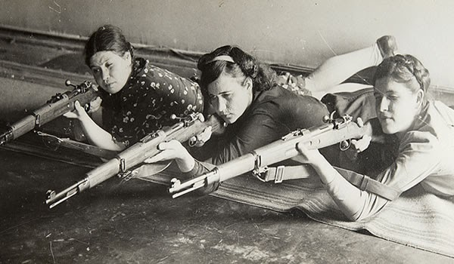
Credit: Fine Art Images/Heritage Images/Getty Images

Soviet-era Communism tended to embrace the equality of the sexes, and perhaps nowhere was this more apparent than in the Russian attitude toward female soldiers. Nearly one million Soviet women took up arms and served on the front lines of World War II as anti-aircraft gunners, snipers, partisan guerrillas and even fighter pilots. More than simply providing the Red Army with an unanticipated boost in numbers, female troops eventually earned a reputation as some of the fiercest fighters on the Eastern Front. Among others, ace pilots Lydia Litvyak and Yekaterina Budanova each downed around a dozen German planes, and sharpshooter Lyudmila Pavlichenko singlehandedly killed more than 300 enemy soldiers. Anxious to prove their worth in combat, women regularly signed up for some of the most hazardous combat positions. For example, one of the most feared Soviet units was an all-female regiment of dive-bombers known as the “Night Witches,” who flew sluggish biplanes on nighttime bombing raids behind German lines.

5. Stalin ordered Soviet forces to fight to the last man.
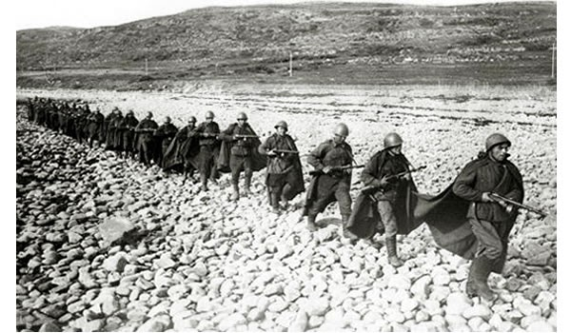
After seeing millions of Soviet troops captured in the early days of the German blitzkrieg, Joseph Stalin issued August 1941’s “Order No. 270,” which proclaimed that any troops who surrendered or allowed themselves to be captured were traitors in the eyes of the law and would be executed if they ever returned to Russia. The dictator later upped the ante with July 1942’s famous “Order No. 227,” better known as the “Not One Step Backward!” rule, which decreed that cowards were to be “liquidated on the spot.” Under this order, any troops who retreated were to be shelled or gunned down by so-called “blocking detachments”—special units who were positioned behind their own lines and charged with shooting any soldier who tried to flee. Stalin’s draconian orders were designed to increase the Red Army’s fighting spirit, but they weren’t empty threats. According to some estimates, Soviet barrier troops may have killed as many as 150,000 of their own men over the course of the war, including some 15,000 during the Battle of Stalingrad.

6. It included the largest tank battle in military history.
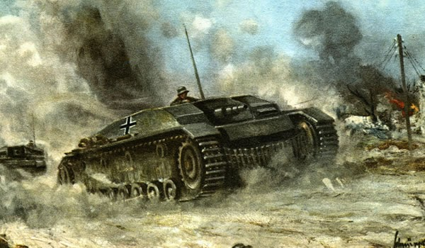
The Eastern Front is best known for the multi-year Siege of Leningrad and the bloody Battle of Stalingrad, but it was also the site of the largest armored confrontation of all time. During July 1943’s Battle of Kursk, some 6,000 tanks, 2 million men and 5,000 aircraft clashed in one of the most strategically important engagements of World War II. The campaign began when the Germans set their sights on a 70-mile-long salient, or bulge, in the Soviet lines in western Russia. Hitler delayed the attack by several weeks to allow the Nazis’ new Tiger tanks to reach the front, which gave the Soviets time to fortify the entire region. When the German offensive finally commenced, they were met by a storm of mines and artillery fire that eventually destroyed hundreds of tanks and left a total of some 350,000 men dead on both sides. Unable to match the Soviets in a contest of attrition, the Germans reluctantly withdrew from the region on July 13. The retreat marked the last gasp of Nazi offensive operations in the East.

7. Both sides engaged in large-scale atrocities and war crimes.
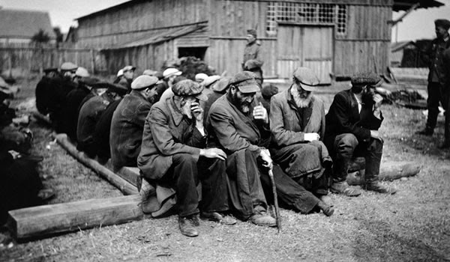
Jewish Russian peasants captured by German army during World War II. (Credit: Nigel Dobinson/Getty Images)
The struggle for the Eastern Front was bigger and costlier than the fighting in the West, but it was also significantly more brutal. Both sides flouted international law and practiced institutionalized acts of cruelty against enemy troops, prisoners and civilians. The Germans wiped out scores of villages during their advance through Russia, and Jews and other minorities were regularly rounded up and shot or poisoned in mobile gassing vans. Other cities were looted or starved into submission, most famously Leningrad, where as many as one million civilians may have perished during a 28-month siege. The Red Army responded by giving no quarter during the Soviet push to Berlin in 1945, when hundred of thousands of German civilians were shot, burned alive in buildings, crushed by tanks and even crucified. According to some studies, Soviet troops may have also been responsible for the rape of some two million German women during the last days of the war.

8. The last German POWs weren’t released from the Soviet Union until 1956.
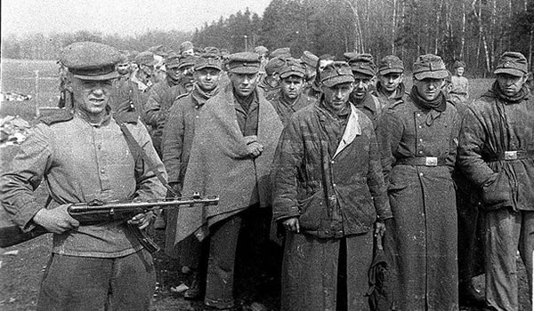

While the western Allies released their final World War II prisoners in 1948, many German POWs in the U.S.S.R. were kept under lock and key for several more years. Most were used as slave labor in copper or coal mines, and anywhere between 400,000 and one million eventually died while in Russian custody. Some 20,000 former soldiers were still in Soviet hands at the time of Stalin’s death in 1953, and the last 10,000 didn’t get their freedom until 1955 and 1956—a full decade after the war had ended.

Did You Know?
- Of the estimated 60-70 million deaths caused by World War II, around half occurred on the Eastern Front. The struggle was especially hard on the Soviets, who may have seen as many as 25 million troops and civilians killed—nearly 15 percent of their entire pre war population. The Eastern Front was also responsible for the lion’s share of the German military deaths. All told, eight out of every ten German troops killed in World War II perished while fighting the Soviets.

9. Battle of Stalingrad

https://www.youtube.com/watch?v=49fdHDBJCFI
WWII: Russia’s Role

1. Why do you think Joseph Stalin disregarded early warnings of the German attack?
2. Why did most people believed Germany would quickly crush the Soviet Union?
3. How did weather conditions play a crucial role in the Soviet victory?
4. What role did Russian women play in WWII?
5. Why did Stalin order the killing of his own soldiers?
6. What mistake did Hitler make in the battle of Kursk?
7. Why do you think the Soviet and Nazi armies were so brutal to one another?
8. Why do you think the Soviets held German soldiers for more than a decade after the end of WWII?
9. Why is the Battle of Stalingrad considered the most important battle of WWII?

TEES: Why do you think the Soviets call WWII the “Great Patriotic War?”

T  Thesis | E  Explain | E  Evidence | S  Summary
-Identifies the argument or main point  -Establishes a controlling idea, which makes a specific comment about a topic | -Specifies and narrows the topic sentence  -Clarifies by describing in more detail and/or revealing relevant facts | -Support with specific information from the text or lesson  -Select appropriate historical information to support thesis | -Summarizes the main point(s)  -States the paragraph’s main conclusion, purpose, or idea
1 POINT | 1 POINT | 2 POINTS | 1 POINT

