Air Pollution

Sulfur Cycle
Video (no need to draw, just watch): https://www.youtube.com/watch?v=TNTTJ4N3kIE (1.54)

Key Points:
- SO2 (sulfur dioxide) is released from burning fossil fuels and volcanoes
- SO2 reacts with H2O in atmosphere to make H2SO4
- H2SO4 (sulfuric acid) falls as acid precipitation
- Sulfur is used to make 2 amino acids
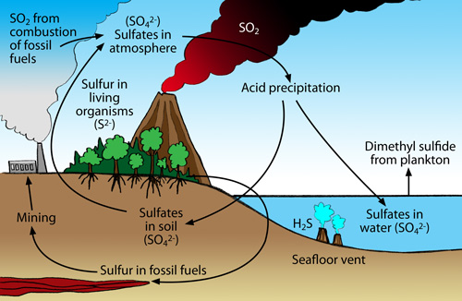

4/15 The Basics

Air pollution measurement units = ppm (parts per million), ppb (parts per billion)

Acute - “short term” - effects which occur immediately after exposure
Ex.

Chronic - “long term” - such as years of exposure to low levels of pollutants that eventually have an effect on health
Ex.

TD50 - Toxic Dose for 50% of the test group, aka 50% get sick / react in some way

LD50 - Lethal Dose for 50% of the test group, aka 50% die

Primary pollutant - pollutants that are released in that form

Secondary pollutant - pollutants that were released as one form, but changed to another after reacting with another substance
- Ex. Sulfur dioxide + H2O = Sulfuric acid (acid precipitation)

Clean Air Act - U.S, 1970, (amended 1990) controls air pollution on a national level by setting allowable levels and mitigation practices

National Ambient Air Quality Standards (NAAQS) - a list of the 6 most common air pollutants “criteria pollutants” listed by the EPA and what are safe levels / what to do to reduce them
- Carbon monoxide, lead, ground-level ozone, particulate matter, nitrogen dioxide, sulfur dioxide
- CO P S N Oz L…..acronym?

POLLUTANT | SYMBOL | EFFECTS | SOURCE | MITIGATION
Carbon Monoxide | CO | Occupies site of oxygen on hemoglobin causing dizziness | Incomplete combustion of fuel | Better ventilation, more complete burning systems, catalytic converter in vehicle (oxidation of CO to CO2)
Particulates | N/A | Respiratory irritation | Incomplete combustion | Wet scrubbers, electrostatic precipitators, cleaner burning systems
Nitrogen oxides / Nitrogen dioxide | NO2 / NOx | Respiratory illness (also form smog, acid rain, ground level ozone) | vehicle emissions, tobacco smoke and burning fossil fuels | Catalytic converters on vehicles (reduction of NOx to N and O)
Sulfur dioxide | SO2 | Respiratory illness, damage to plant leaves | Burning coal, volcanoes | Using “clean” coal
Ozone (ground level) | O3 | Respiratory illness, harms sensitive vegetation | VOC + NOx + Sunlight.  Also plants. (bastards) | Reduce VOC use and production of NOx (catalytic converters)
Lead | Pb | Developmental delays | Paint, *gasoline, solder | Stop using
*1996 ended leaded gasoline in on-road vehicles...resulting in one of the most successful reductions in air pollutants in U.S. history

4/17 Pollution Because of the Sun

VOC’s - (Volatile Organic Compounds) substances which are volatile (evaporating quickly from a liquid or solid state), human-made (typically “smelly”, ex. Paint, not acutely toxic but long-term effects such as respiratory / allergic reaction and naturally occurring (plant communication)
- Examples of VOC’s:
- CFCs - chlorofluorocarbon (used as refrigerants, propellants, solvents)
  - Montreal Protocol (1989) phased out CFC’s to protect stratospheric ozone

- formaldehyde - ( CH₂O) used as a preservative, highly toxic in any form of exposure (carcinogen, eye and respiratory irritant)

photochemical oxidants - chemicals that result from sunlight, NOx and VOCs
- Ex. ground level Ozone

Ground level
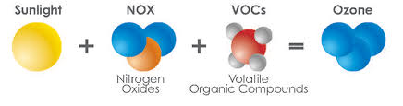
https://www.washoecounty.us/health/programs-and-services/air-quality/nozone.php
- Ex. PANs - (peroxyacetyl nitrate) respiratory and eye irritation, inhibits photosynthesis
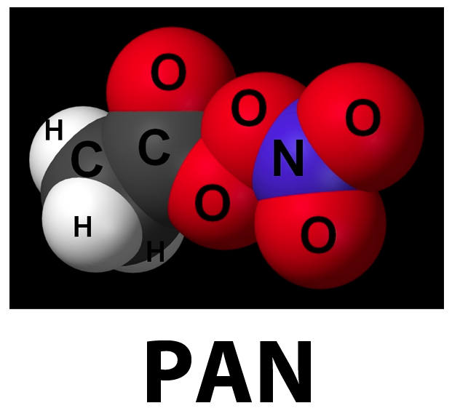
http://elte.prompt.hu/sites/default/files/tananyagok/AtmosphericChemistry/ch06s04.html
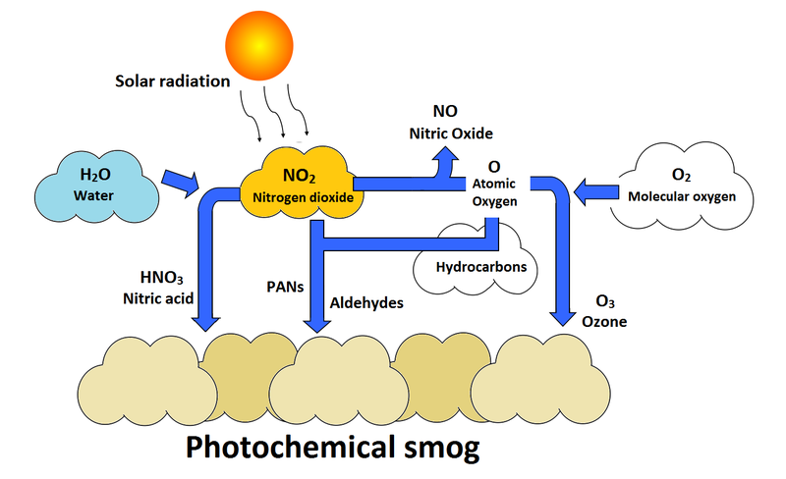
https://energyeducation.ca/encyclopedia/Photochemical_smog

Smog:
Grey vs brown (photochemical smog)

temperature inversion - when a layer of warm air sits over a layer of cold air, trapping chemicals close to the ground….creating smog (think LA, California)

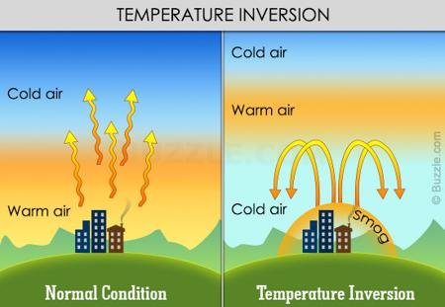

Check this out! https://www.youtube.com/watch?v=LPvn9qhVFbM (2:49)
(Nice visual of temperature inversion...experiment)

Catalytic Converters - added to vehicle exhausts to reduce harmful smog-causing emissions
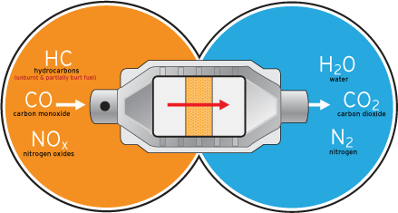
(Inside includes transition metals such as platinum)

4/15 Random Pollution

Asbestos - naturally occurring mineral, used for heat resistance and insulating properties (fire-proof vests - home construction) causes cancer

radon (don’t forget about this from Nuclear unit)

acid precipitation - snow, sleet, rain, fog which is below 5.6
- Effects: damage to plant leaves, lowering pH of soil affects plant growth (particularly sugar maples), acidic water leaches heavy metals out of soil and rock further poisoning waterways

Buffering capacity - the result of limestone neutralizing acid precipitation, thus
lessening the effects of acid precipitation on waterways

indoor air pollution - pollution occurring indoors resulting from incomplete combustion of cooking fires and heating (typically particulates and CO)
- Sick Building Syndrome - sickness (headache, nausea, etc) caused by off-gassing of new building materials such as furniture and carpets

urban heat island (again)

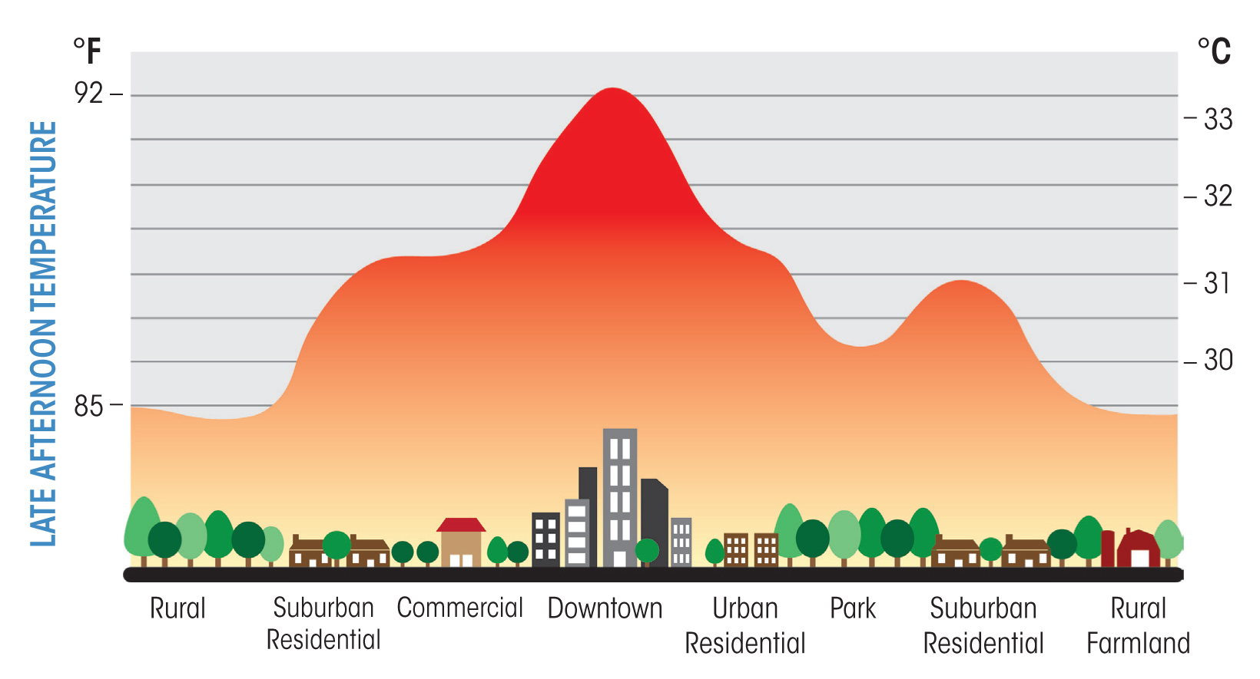
http://www.c3headlines.com/global-warming-urban-heat-island-bias/

Noise pollution - IT IS WHAT IT SOUNDS LIKE
- Sources: vehicles, construction, manufacturing, etc.
- Effects: hearing loss, persistent ringing in ears
- Control measures: technology

Light pollution - effects on migration (and baby turtles)

http://www.citymetric.com/horizons/light-pollution-making-us-sick-915

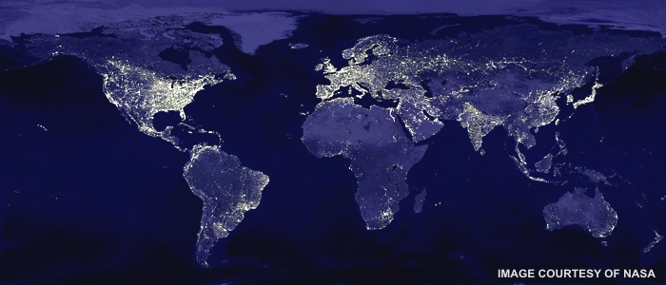
http://heimhenge.com/skylights/2012/01/09/qa-holiday-decorations-and-light-pollution/

POLLUTANT | SYMBOL | EFFECTS | SOURCE | MITIGATION
Carbon Monoxide | CO | Occupies site of oxygen on hemoglobin causing dizziness | Incomplete combustion of fuel | Better ventilation, more complete burning systems, catalytic converter in vehicles
Particulates | N/A | Respiratory irritation | Incomplete combustion | Wet scrubbers, electrostatic precipitators, cleaner burning systems
Nitrogen oxides / Nitrogen dioxide | NO2 / NOx | Respiratory illness (also form smog, acid rain, ground level ozone) | vehicle emissions, tobacco smoke and burning fossil fuels | Catalytic converters on vehicles (reduction of NOx to N and O)
Sulfur dioxide | SO2 | Respiratory illness, damage to plant leaves | Burning coal, volcanoes | Using “clean” coal
Ozone (ground level) | O3 | Respiratory illness, harms sensitive vegetation | VOC + NOx + Sunlight.  Also plants. | Reduce VOC use and production of NOx (catalytic converters)
Lead | Pb | Developmental delays | Paint, *gasoline, solder | Stop using

