Lesson 3: Practice Explaining Symbols Name:

Directions: Remember that a symbol is an object with both a literal and figurative meaning; that is, it represents both itself and something else. Using the sentence frame provided, explain both the literal and figurative meaning of each symbol provided below.

EXAMPLE OF SYMBOL |  |  | EXPLANATION OF THE SYMBOL
 |  | Literally, this is an image of a circle with a triangle
 |  | inside it; but figuratively, it is associated with playing
 |  | a video.
 |  | Literally, this is an image of
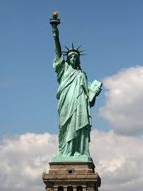 |  | but figuratively, it is associated with,
 |  | Literally, this is an image of
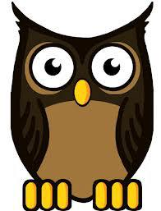 |  | but figuratively, it is associated with
 |  | Literally, this is an image of
 |  | but figuratively, it is associated with,
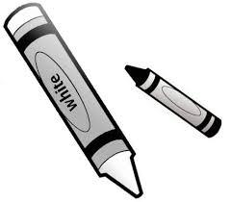
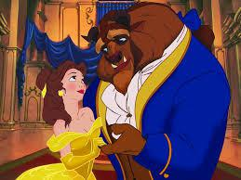 |  | Literally, this is an image of
 |  | but figuratively, it is associated with,

59

Analyzing Symbols in To Kill a Mockingbird

Directions: For each of the following symbols, provide an illustration, two quotations (including page numbers), and an explanation of who or what the symbol represents.

 | Symbol |  | Illustration | Two Quotations |  | Who or What Does the
 |  |  |  | (including page numbers) |  | Symbol Represent?
 |  |  |  | “If she found a blade of
 |  |  |  | nut grass in her yard it
 |  |  |  | was like the Second
 |  |  |  | Battle of the Marne:
 |  |  |  | she swooped down
 |  |  |  | upon it with a tin tub
 |  |  |  | and subjected it to
 |  |  |  | blasts from beneath
 |  |  |  | with a poisonous
Miss Maudie’s Nut Grass |  |  |  | substance she said was
 |  |  |  | so powerful it’d kill us
(Chapter 5)
 |  |  |  | all if we didn’t stand out
 |  |  |  | of the way” (42).
 |  |  |  | “Why can’t you just pull
 |  |  |  | it up?” . . . “Why, one
 |  |  |  | sprig of nut grass can
 |  |  |  | ruin a whole yard. Look
 |  |  |  | here. When it comes
 |  |  |  | fall this dries up and the
 |  |  |  | wind blows it all over
 |  |  |  | Maycomb County” (42).
The Mockingbird (Chapter
 | 10)

 |  |  | Resource 3.14
Symbol | Illustration | Two Quotations | Who or What Does the
 |  | (including page numbers) | Symbol Represent?
 |  | “. . . I hope and pray I
 |  | can get Jem and Scout
 |  | through it without
 |  | bitterness, and most of
 |  | all, without catching
 |  | Maycomb’s usual
 |  | disease. Why
 |  | reasonable people go
 |  | stark raving mad when
 |  | anything involving a
 |  | Negro comes up, is
 |  | something I don’t
 |  | pretend to understand”
Tim Johnson, the Mad Dog |  | (88).
(Chapter 10)

