Nombre:__________________________ Periodo:___________

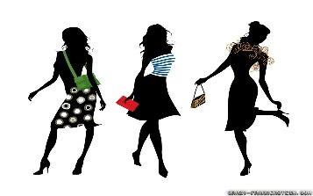
El Desfile de la Moda:

Overview: You will be creating your own collection for a fashion show. You will first design a few stylish “looks.” You may do so by…
- Drawing these fashionable looks (on stick figures if necessary)
- Creating these looks on Paint
- Dressing up dolls with items around the house
- Creating actual clothing for you to wear

You will then write a paragraph describing your overall collection, and each model’s specific look. The organizer will help you organize your thoughts.

Lastly, please record yourself narrating this fashion show. You may use FlipGrid https://flipgrid.com/991dc67f or present on Zoom.

¡Buena suerte, chicos!

Organizer:
Los Temas de la Colección:__________________________________________
___________________________________________
___________________________________________

La Ropa Específica:

El Modelo #1:___________________________________________________

El Modelo #2:___________________________________________________

El Modelo #3:___________________________________________________

El Modelo #4:___________________________________________________

La Rúbrica
Category | 5 | 3 | 1
Fulfills task | Project completely fulfills task | Project partially fulfills task | Project does not fulfill task
Vocabulary | Uses frequent unit and review vocabulary | Uses some unit and review vocabulary | Uses little unit/review vocabulary and/or uses frequent Google Translate
Conjugations | Few errors in conjugation | Some errors in conjugation; does not affect comprehensibility | Frequent errors in conjugation; affects comprehensibility
Other Grammar | Few errors in spelling, agreement, word use, etc. | Some errors in grammar | Frequent errors in gramamr
Creativity | Both looks and descriptions go above-and-beyond expectations | Looks and descriptions show some creativity | Looks and descriptions show little creativity
Presentation | Presentation is audible, enthusiastic, and comprehensible | Presentation is enthusiastic, but lacks some audibility or comprehensibility. | Presentation is difficult to understand

Puntos:__________/30

La Nota: Los Comentarios:

